|  |  |  |  |  |  |
| --- | --- | --- | --- | --- | --- |
| Date | 1-Dec-22 | | | Tester Name | Richard Belanger |
| Environment | Penfax - Test | | | Login used | TEST2 |
| Operating System | Windows | Version: | Update: | | |
| Software Used | Edge | Version: | Update: | | |
| Not Applicable | Version: | Update: | | |
| Release version | 22.4.1 | | | | |
| Title | M8.15 Casual member eligible to retire unreduced pension single has low salary | | | | |
| Test Type | Regression | | | | |
| Test Scenario | Terminate member for the purposes of Retirement | | | | |
|  |  | | | | |
| Expected Results | The member will be terminated and placed on Pension | | | | |
| Pass/Fail | Pass | | | JIRA# | N/A |

Describe your steps with screenshots:

Member is Casual and Eligible for an Unreduced Pension

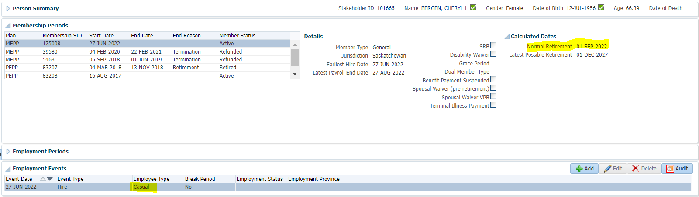

Terminate member for purposes of retirement

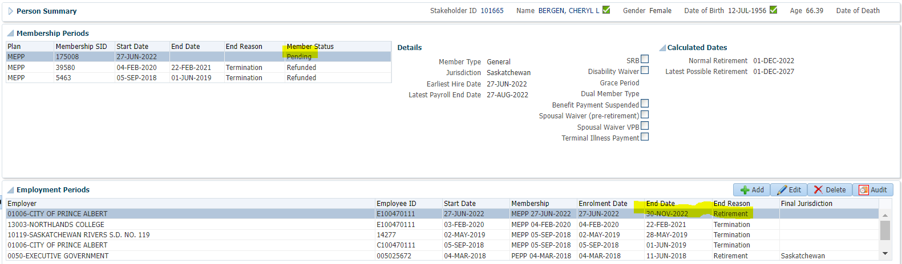

To Benefit Calculation>Calculate

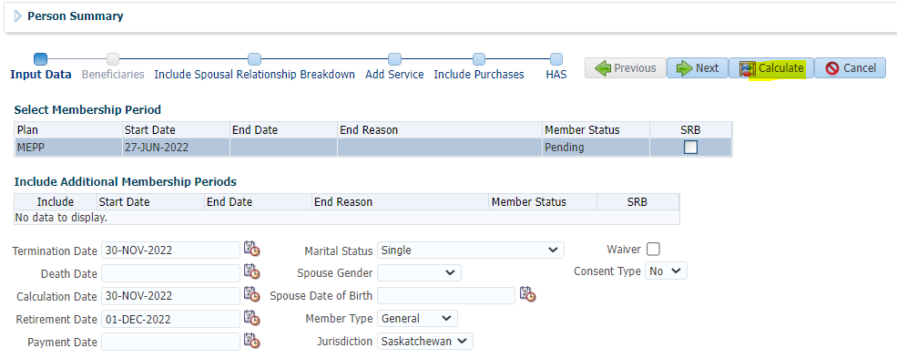

Process>Member qualifies for a Refund

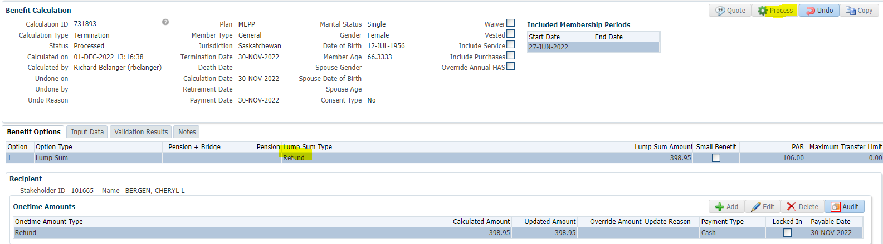

Processed>To Benefit Selection

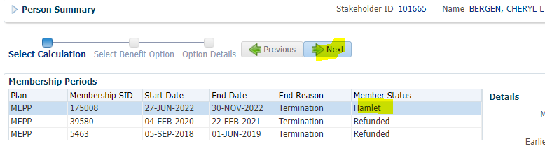

Next

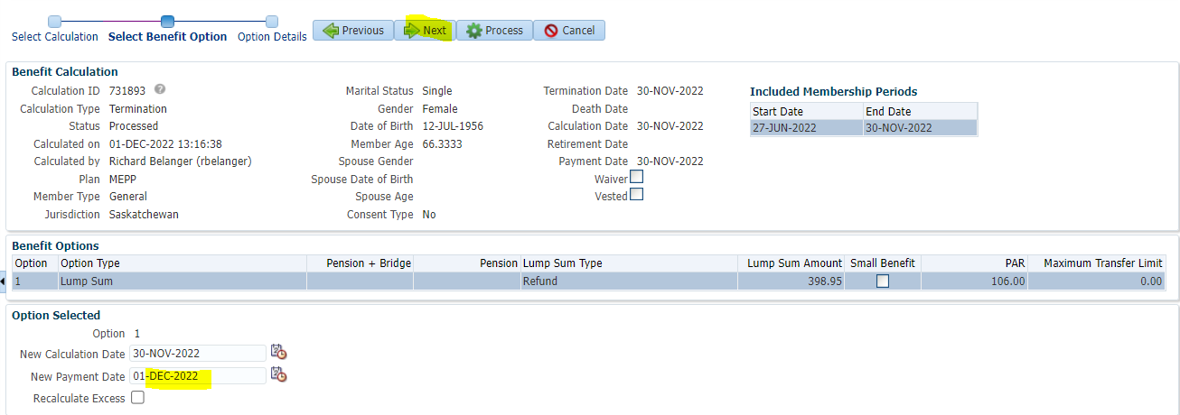

Payment Instructions added; Tax Instructions added>Process

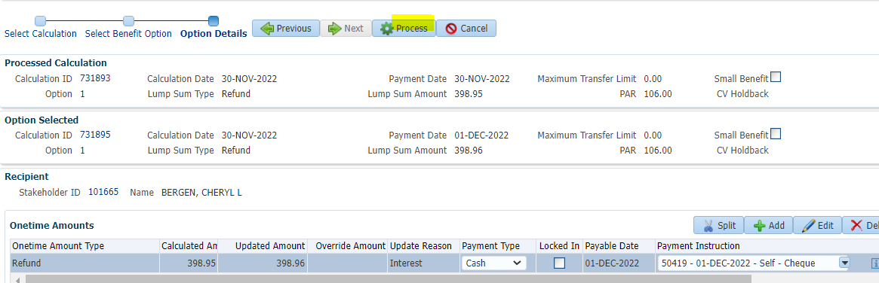

Member is Refunded

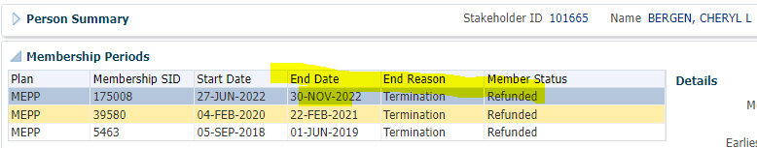

To Benefit Recipient>Onetime Amounts>Approved



To Summary to Authorize>Authorized

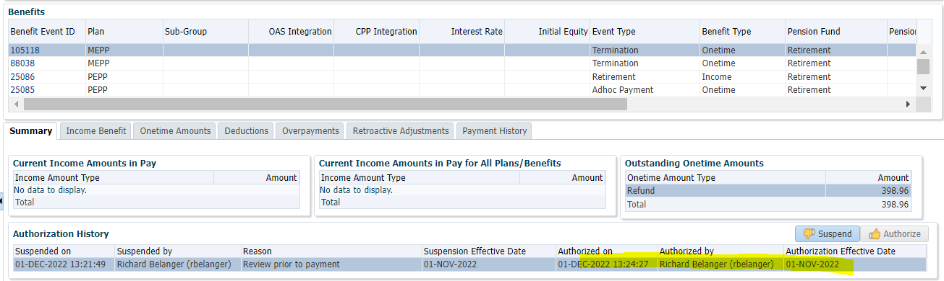

Payment Produced>Payment History with Income Tax taken

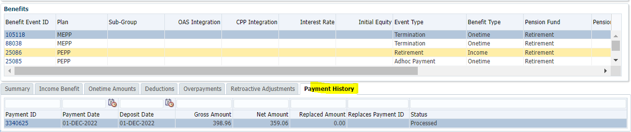

Tax Rates

0.00-4,999.99 = 10%

5,000.00- 14,999.99 = 20%

15,000.00+ = 30%

398.96 x 10% = 39.90; 398.96 – 39.90 = 359.06